**Stream Server setting up:**

1. Insta 360 camera connection:

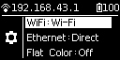

Go to camera setting menu, **set connection as WiFi mode**, namely the mode to connecting the external WiFi. Then **change the Ethernet mode to DHCP**. Select WiFi key in the homepage, and **press SETTING key**, to enter the screen where the system is waiting for the user scanning the camera’s WiFi information (SSID and password). The user could use the QR generation function of cell phone APP.

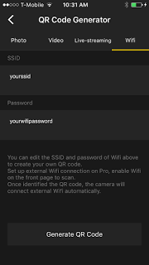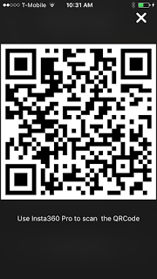

Set SSID and password of the external WiFi to be connected, and generate a QR code for identification by the camera. After successful scanning, the camera will be automatically connected with the external network.

1. Open the Nginx server: Download nginx server from <https://github.com/arut/nginx-rtmp-module>, override the configure file with the file provided in our project repository: /NginxServer/conf/nginx.conf

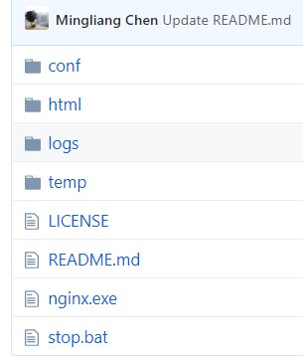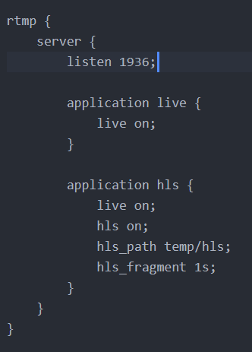 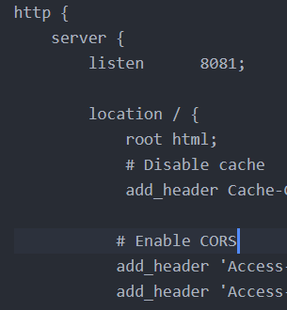

Which let the server listen on port 1936, and allow HLS connection on port 8081.

While your pc and Insta360 pro camera are under the same LAN, run Nginx.exe. You could check the process from windows Task Manager.



1. Camera signal feed to server: Using official mobile app or pc client to connect to Insta360 pro. Select Live menu, chose streaming mode to **Custom Rtmp Server and Live-stream Format as RTMP.**

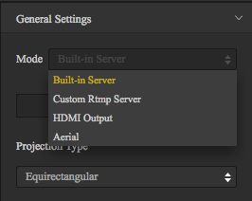 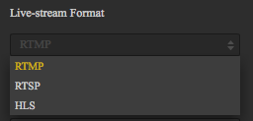

Assume **SERVERIP** represents the IP address of your pc which runs the Nginx server. You should fill in the streaming service URL as : rtmp:// **SERVERIP:**1936/hls and Stream Key: **test**

If you are using the mobile app, then there is no field for Stream Key. You should change the stream URL to: rtmp:// **SERVERIP:**1936/hls/test

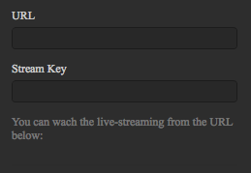 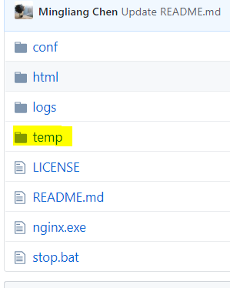

After finishing all the settings, you could click **Live** button to start streaming.

You could check the your Nginx installation folder, the m3u8 index file and ts video file should be generated in /temp/hls folder.

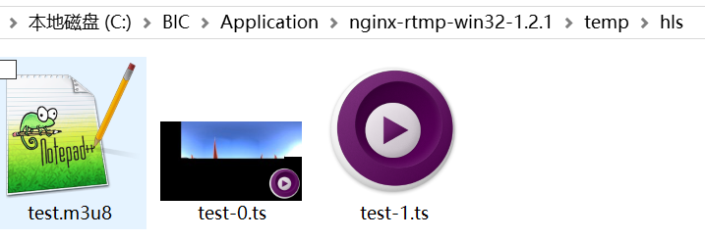

**User Client connection:**

1. While the Flask service is running, modify the web client file in our project repository: /PCServer/templates/index.html

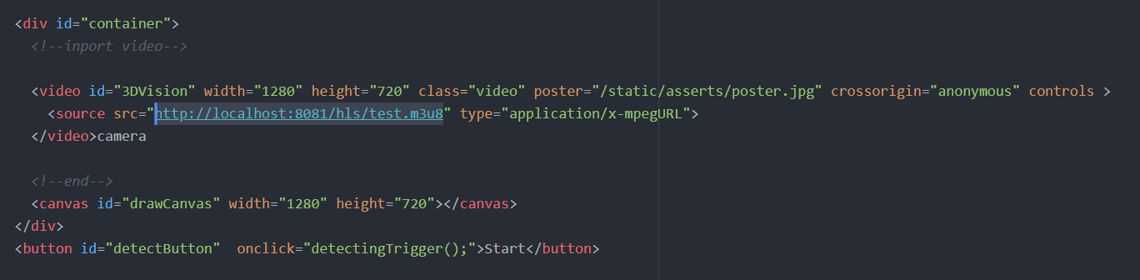

Modify the video element(ElementID: 3DVision) source URL to :

<http://SERVERIP:8081/hls/test.m3u8> to access the hls index file.